**PROJECT REPORT**

1. **INTRODUCTION:**
   1. **OVERVIEW**

TRAVELTRAX helps corporations gain a better understanding of corporate travel data and more effectively manage their global T&E costs. TRAVELTRAX provides users with clear and concise insight into global travel programs for corporations using multiple travel agencies, corporate cards, and/or expense reporting platforms through seamlessly aggregating, consolidating, and enhancing data from over 150 sources.

* 1. **PURPOSE**

Tourism and travel have undergone tremendous growth and diversification to become a major force in the international economy. Many developing countries have increased their presence in the market, particularly as travelers have expanded beyond the more traditional destinations in order to seek out new places and experiences.

1. To know how to use of Zoho books in the field of travel agencies.
2. To get the practical experience in preparing and maintaining zoho books at travel trax.
3. To get the practical experience in getting report.
4. To get the knowledge about empathy map and brain storming map.
5. To get overall experience in zoho book a online accounting applications.
6. To get a business idea.
7. To get experiance in accounting field.
8. **PROBLEM DEFINITION & DESIGN THINKING**
   1. **Empathy Map**

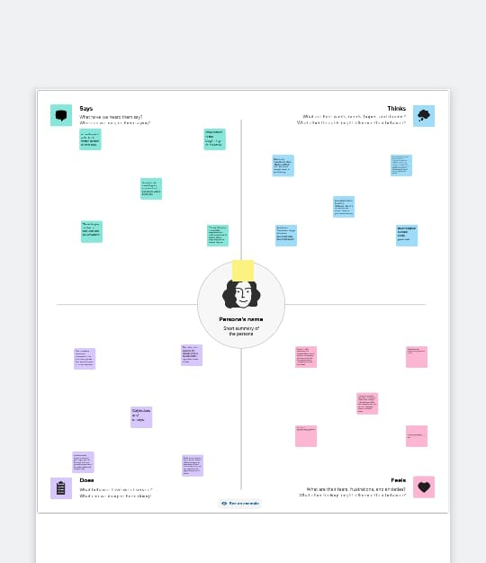

* 1. **Ideation & Brainstorming Map**

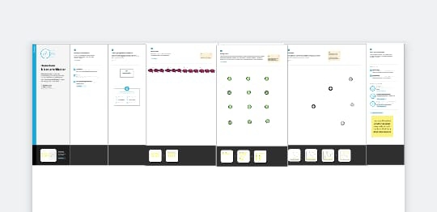

**3 .RESULT**

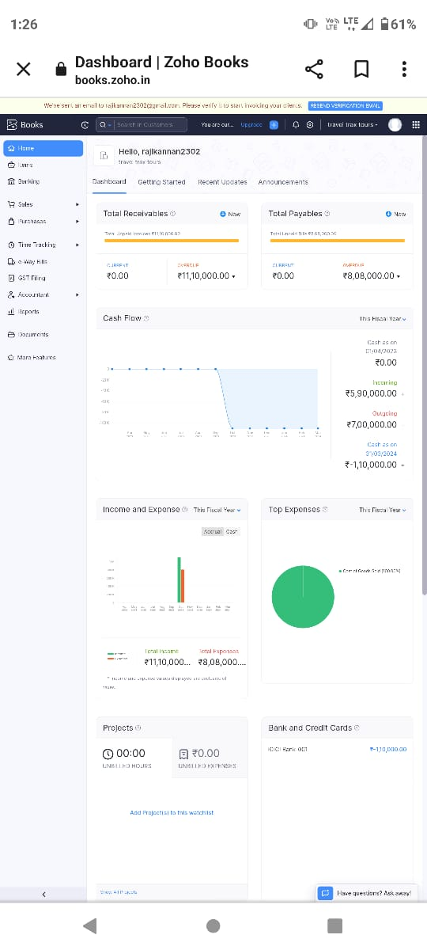

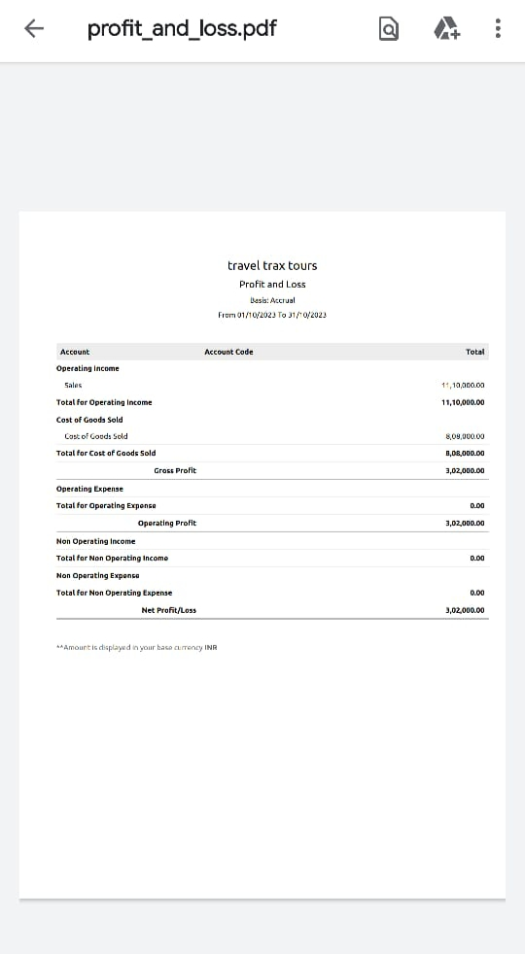

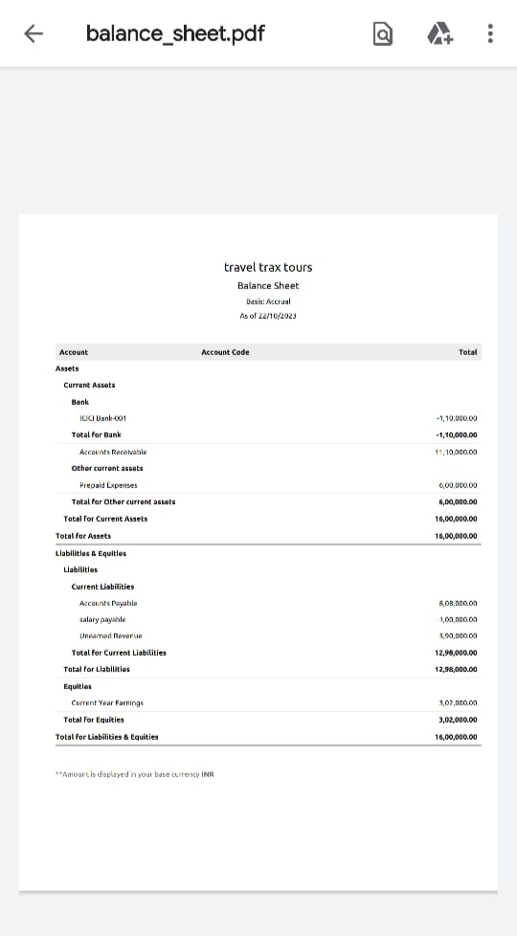

**4. ADVANTAGES & DISADVANTAGES**

One of the most common hobbies is Travelling. People love & enjoy traveling, exploring, and getting to know other countries cultures.Traveling abroad involves mixed emotions. On one way, you are delighted to go to a foreign country. But on the other hand, you have anxiety & worry about going abroad. If you are planning to travel abroad, here are some advantages and disadvantages of traveling abroad

Advantages :

1. It is easy to use.
2. It is easy to understand
3. It is simple to use

Disadvantages:

1. Before that a practice ios need to do that.
2. Proper traning is needed

# .APPLICATIONS

There are many mainstream Zoho books App platforms that cater to tourists, but very few that provide inspiration for travellers as well as help them share their experiences. My Trax app aims to solve this problem and provide a platform for aviod travellers around the world.

# .CONCLUSION

In conclusion, travel and tourism have significantly shaped the global economy and brought people together from different cultures and backgrounds. The industry has shown remarkable resilience in the face of various challenges, such as the COVID-19 pandemic, and has continued to grow and evolve. In travel agency zoho books which helps a lot.it is very use ful and help to get report instance.as a student a get apractical experienceand get a new skill for online account software.

# .FUTURE SCOPE

While experience is a significant factor in the field of Travel and Tourism courses, the scope of Tourism includes endless job opportunities that candidates can avail in both private and public sectors after pursuing Travel and Tourism courses.